Camunda 8 - Working with the Zeebe API (CLI Client)

What Will I Learn?
This course will provide you with a brief introduction to working with the Zeebe API using the Zeebe CLI (zbctl).
You will use zbctl to perform an end-to-end test against a process definition. This will allow you to gain an understanding of the actions required to connect to the Zeebe engine and test your process applications.

What Will I Learn?
At the end of this course you will be able to:
- Access a Camunda Environment
  - Access Console
  - Access Operate
- Deploy a Camunda Application
  - Deploy a Process Definition using the Zeebe CLI
- Test a Process Definition
  - Start a Process Instance using the Zeebe CLI
  - Activate a Job using the Zeebe CLI
  - Complete a Job using the Zeebe CLI
  - Fail a Job using the Zeebe CLI
  - Create a Job Worker using the Zeebe CLI
  - Send a Message Event using the Zeebe CLI
- Monitor a Process Definition
  - View a Process Instance using Operate
  - Retry an Incident using Operate
  - Cancel a Process Instance using the Zeebe CLI
  - Delete a Process Instance using Operate
Business Requirement
We will be using a fictitious organization; Camundanzia, as the scenario for this course.

Camundanzia
Scenario
The Camundanzia insurance company would like to automate the assessment of Car Insurance Applications as much as possible. Complex applications will still be manually reviewed by an employee.
A Camundanzia Business Analyst has already created an initial draft of the process model in BPMN. The next step is to ensure that all implementation details have been added correctly.

User Story
One simple User Story to capture Camundanzia's requirements can be found below:
User Story
- As an Administrator
- I want to launch a process instance with the Zeebe CLI
- So that I can confirm that the process works as expected

Acceptance Criteria
The initial acceptance criteria that we are working to can be found below:
- An Applicant is able to submit a Car Insurance Application
- The Credit Score of the Applicant can be retrieved automatically
- A Clerk is able to review complex applications and decide whether the Applicant will be accepted or not
- An Applicant is able to cancel their application
Outline Solution
We now have a clear set of requirements and acceptance criteria for testing the Camundanzia Car Insurance Application Process.
We will use a draft of the Car Insurance Application Process as a mechanism to explore the commands available in the Zeebe CLI Client.

Camundanzia
Scenario
Imagine that you have recently joined Camundanzia as a new Administrator and have been assigned to the Camunda project team. Your first assignment is to understand the Car Insurance Application Process and confirm that it is working as expected and that all required implementation details have been provided.
Fortunately for you, a more experienced Camunda Administrator has provided you with a few hints on how to get started. Your task is to complete the required tasks based upon the outline that has been provided.

Car Insurance Application

Process Diagram
The Car Insurance Application Process can be obtained from this GitHub Repository and can also be seen in the diagram below.
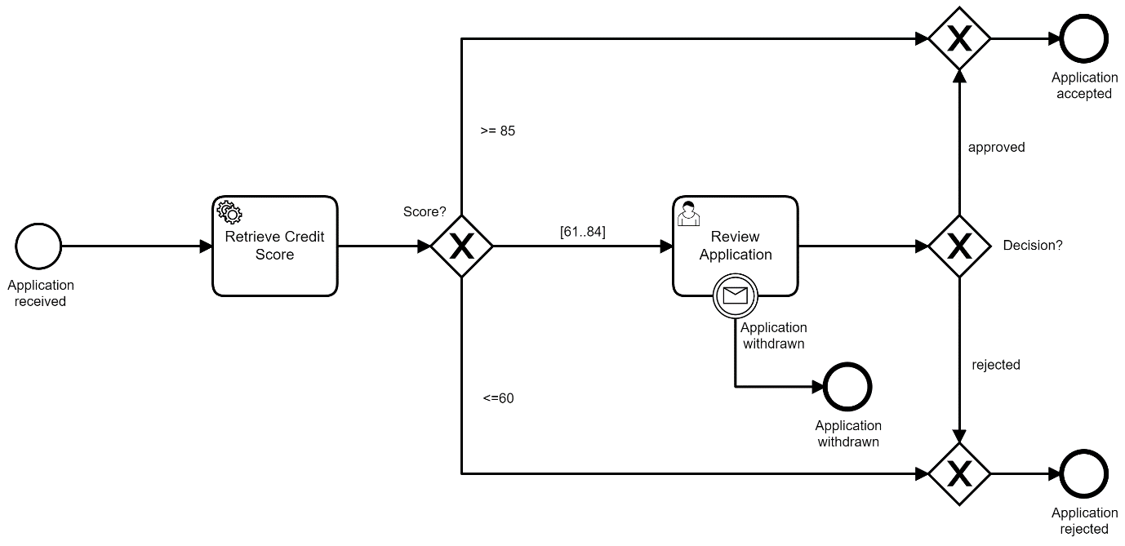
applicationProcess.bpmn

Process Variables
The process is started with the following variables:
Variable | Type | Description
applicationId | String | Unique ID to track the application
applicationName | String | Name of the Applicant
applicantEmail | String | Email of the Applicant
applicantAge | Integer | Age of the Applicant

Business Logic
The majority of the business logic for the process is captured in the following elements:
Name | Type | Description
Application Received | Start Event | The process starts when an Application is received
Retrieve Credit Score | Service Task | Returns a Credit Score (Integer) between 0 and 100
Review Application | User Task | If the Credit Score is between 61 and 84, a Clerk must review the application and make a decision
Application Withdrawn | End Event | An Application may be withdrawn if it is in the Review Application state

Outline Solution
The more experienced Administrator has provided an overview of the work that must be completed for each of the stated acceptance criteria. This covers the configuration that you, the new Administrator must perform and the Camunda components that offer the required functionality.

Connect to Zeebe Engine using the CLI Client
We will be testing the solution by issuing commands to a Zeebe Cluster using the Zeebe CLI Client.
Install Zeebe CLI Client
Install the Zeebe CLI Client (zbctl)
Configure Cluster Credentials
Configure the Zeebe CLI Client
Connect to Cluster
Obtain information from a Zeebe Cluster

Deploy and Start the Process
Once the connection to the Zeebe Cluster has been established, we can start to validate the Car Insurance Application Process.
Deploy Process Definition
Deploy the Car Insurance Application process definition.
Start Process Instance
Start a Car Insurance Application process instance.
Cancel Process Instance
Cancel a Car Insurance Application process instance.

Simulate Retrieve Credit Score
We will simulate the behavior of Retrieve Credit Score to validate the process logic before developing a Job Worker.
Activate Job
Activate a Retrieve Credit Score Job
Complete Job
Complete a Retrieve Credit Score Job
Fail Job
Fail a Retrieve Credit Score Job

Configure Worker for Service Task
We will configure a Worker to process the Retrieve Credit Score Service Task.
Create Worker
Register a Worker that will handle the Retrieve Credit Score Jobs.

Review User Task
In addition to the Tasklist, User Tasks can also be completed by using the Zeebe API.
Complete User Task
Complete the Review Application User Task.

Send BPMN Message
Finally, BPMN Message Events can also be thrown using the Zeebe API.
Send Message
Throw a message which will be caught by the Application Withdrawn Boundary Event.

Development Plan
Now that we have identified the steps to validate our solution, we can create a plan of the work that needs to be performed and the tools that will be required.
- Install Zeebe CLI Client
  - This will be performed using the tools appropriate for your machine
- Configure Cluster Credentials
  - This will be performed using the Console and zbctl
- Connect to Cluster
  - This will be performed using zbctl
- Deploy Process Definition
  - This will be performed using zbctl and Operate
- Start Process Instance
  - This will be performed using zbctl and Operate
- Cancel Process Instance
  - This will be performed using zbctl and Operate
- Activate Job
  - This will be performed using zbctl and Operate
- Complete Job
  - This will be performed using zbctl and Operate
- Fail Job
  - This will be performed using zbctl and Operate
- Create Worker
  - This will be performed using zbctl and Operate
- Complete User Task
  - This will be performed using zbctl and Operate
- Send Message
  - This will be performed using zbctl and Operate
Ready to get started? Then proceed to the next lesson.

Installation
zbctl is a Command Line Interface (CLI) which can be used to interact with Camunda using the Zeebe API. zbctl connects to a Camunda Cluster using gRPC which is a high-performance, open-source RPC framework.
Note
The CLI client doesn't support multi-tenancy and can only be used when multi-tenancy is disabled. You can find more details on multi-tenancy here.

Installation
zbctl can be installed locally on your machine using any one of the following methods.
npm
The installation can be done quickly via the package manager npm.
npm i -g zbctl
Binary Installation
You can also download a binary for your operating system from the Zeebe GitHub Releases Page.
Docker
You can also use zbctl with Docker if the direct installation method is unsuitable. You will need to pass in your client credentials using the syntax below.

docker run --env ZEEBE_ADDRESS=$ZEEBE_ADDRESS \
--env ZEEBE_CLIENT_ID=$ZEEBE_CLIENT_ID \
--env ZEEBE_CLIENT_SECRET=$ZEEBE_CLIENT_SECRET \
--env ZEEBE_AUTHORIZATION_SERVER_URL=$ZEEBE_AUTHORIZATION_SERVER_URL \
sitapati/zbctl status

Configure Environment Variables
Note
This course is optimized for Camunda SaaS.

When using zbctl, it is recommended that you define environment variables so that you do not need to pass your client credentials with each request.

Download Client Credentials

Whenever you create a new set of client credentials for Camunda SaaS, you have the option to download a file which also contains the required configuration properties.
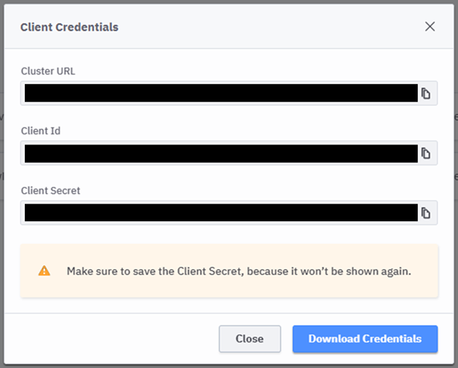

Configure Environment Variables
You can configure environment variables on your machine using the instructions below:
Setting Environment Variables on Linux
After downloading your client credentials, you will need to source them so that they are available to your environment.
source ~/Downloads/CamundaCloudMgmtAPI-Client-test-client.txt
Alternatively, you can execute the following commands using the Terminal so that they are available to your environment.

export ZEEBE_ADDRESS='[Zeebe API]'
export ZEEBE_CLIENT_ID='[Client ID]'
export ZEEBE_CLIENT_SECRET='[Client Secret]'
export ZEEBE_AUTHORIZATION_SERVER_URL='[OAuth API]'
Setting Environment Variables on Windows (Powershell)
Execute the following commands using Powershell so that they are available to your environment.

$env:ZEEBE_ADDRESS="[Zeebe API]"
$env:ZEEBE_CLIENT_ID="[Client ID]"
$env:ZEEBE_CLIENT_SECRET="[Client Secret]"
$env:ZEEBE_AUTHORIZATION_SERVER_URL="[OAuth API]"

Setting Environment Variables on Windows (Command Line)
Execute the following commands using the Command Line (cmd.exe) so that they are available to your environment.

set ZEEBE_ADDRESS=[Zeebe API]
set ZEEBE_CLIENT_ID=[Client ID]
set ZEEBE_CLIENT_SECRET=[Client Secret]
set ZEEBE_AUTHORIZATION_SERVER_URL=[OAuth API]

Obtaining Help
You can obtain help at any time by passing the --help flag along with the command that you wish to execute.
For example, issuing zbctl status --help will show you the help text and available flags for the status command.

Checks the current status of the cluster

Usage:
zbctl status [flags]

Flags:
-h, --help help for status
-o, --output string Specify output format. Default is human readable. Possible Values: human, json (default "human")

Validating the Installation
You can now validate your installation and client credentials by issuing a status command to zbctl; you can see the available commands in the below:

Usage:
zbctl [command]

Available Commands:
activate Activate a resource
broadcast Broadcast a signal
cancel Cancel resource
complete Complete a resource
completion Generate the autocompletion script for the specified shell
create Create resources
deploy Deploys new resources for each file provided
evaluate Evaluate resources
fail Fail a resource
generate Generate documentation
help Help about any command
publish Publish a message
resolve Resolve a resource
set Set a resource
status Checks the current status of the cluster
throwError Throw an error
update Update a resource
version Print the version of zbctl
Passing Client Credentials using Flags
You can also pass the --address, --clientId and --clientSecret as optional flags along with any command, further information can be found here.
Name | Data Type | Description
address | String | Specify a contact point address. If omitted, will read from the environment variable 'ZEEBE_ADDRESS' (default '127.0.0.1:26500')
clientId | String | Specify a client identifier to request an access token. If omitted, will read from the environment variable 'ZEEBE_CLIENT_ID'
clientSecret | String | Specify a client secret to request an access token. If omitted, will read from the environment variable 'ZEEBE_CLIENT_SECRET'

Test the Cluster Connection
To confirm that everything is working as expected, use the following command to connect to your cluster using zbctl

zbctl status
Or, the following if you prefer to pass your client credentials using flags rather than environment variables.

zbctl status --address "[Zeebe API]" --clientId "[Client ID]" --clientSecret "[Client Secret]"
If everything is working as expected, you should see output similar to the below:

Cluster size: 3
Partitions count: 3
Replication factor: 3
Gateway version: 8.3.3
Brokers:
Broker 0 - zeebe-0.zeebe-broker-service.xxx.svc.cluster.local:26501
Version: 8.3.3
Partition 1 : Follower, Healthy
Partition 2 : Follower, Healthy
Partition 3 : Follower, Healthy
Broker 1 - zeebe-1.zeebe-broker-service.xxx.svc.cluster.local:26501
Version: 8.3.3
Partition 1 : Leader, Healthy
Partition 2 : Follower, Healthy
Partition 3 : Follower, Healthy
Broker 2 - zeebe-2.zeebe-broker-service.xxx.svc.cluster.local:26501
Version: 8.3.3
Partition 1 : Follower, Healthy
Partition 2 : Leader, Healthy
Partition 3 : Leader, Healthy
Connected to a Cluster
Congratulations! You have installed zbctl on your local machine, configured the client credentials and obtained the status of your cluster.

Deploy Process
To deploy a process, we will use the DeployResource RPC which deploys one or more processes to Zeebe.
Atomic Transaction
A request to the DeployResource RPC is an atomic call i.e. either all processes are deployed or none are deployed.

Deploy a Process Definition
The following command can be used to deploy a process definition to Zeebe. Ensure that you have downloaded the Car Insurance Application Process and are in the correct directory before executing the command.
Car Insurance Application Process
The Car Insurance Application Process can be obtained from this GitHub Repository

zbctl deploy ApplicationProcess.bpmn
If the deployment was successful, you should see output similar to the below:

{
"key": "2251799813685250",
"processes": [
{
"bpmnProcessId": "ApplicationProcess",
"version": 1,
"processDefinitionKey": "2251799813685249",
"resourceName": "ApplicationProcess.bpmn"
}
]
}
If you now launch Operate, you will see that the Process Definition has been successfully deployed and has been marked as Version 1. Version numbers are automatically set by Zeebe upon deployment.
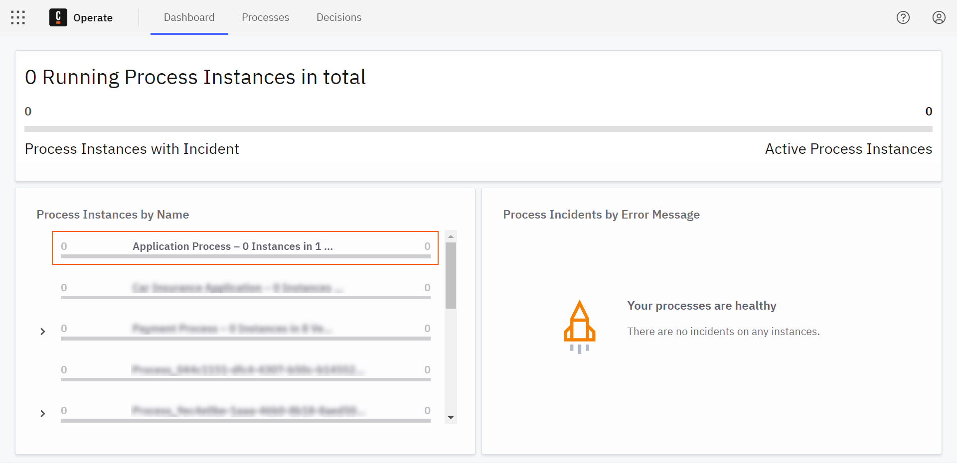
However, you can also see that we don't have any Process Instances yet.
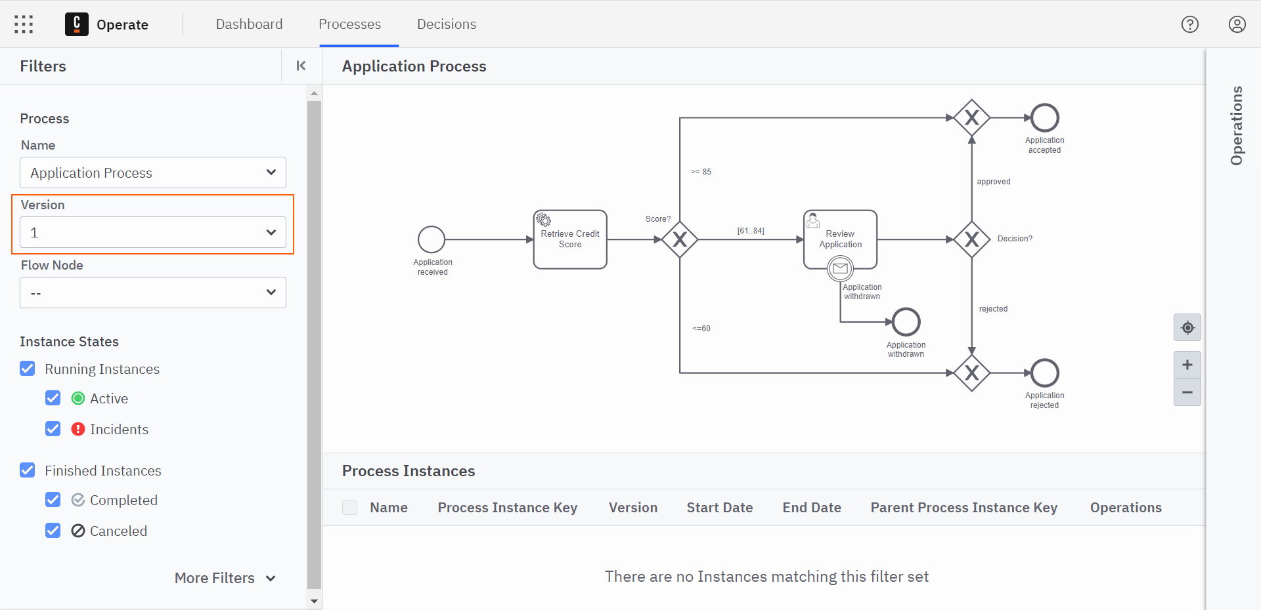

Process Definition Versioning
Let's run the same command again to see how Zeebe manages versioning.

zbctl deploy ApplicationProcess.bpmn
As you can see from the output below, the version of the Process Definition is still Version 1 after deploying for a second time.

{
"key": "2251799813685250",
"processes": [
{
"bpmnProcessId": "ApplicationProcess",
"version": 1,
"processDefinitionKey": "2251799813685249",
"resourceName": "ApplicationProcess.bpmn"
}
]
}
How are Process Definitions versioned by Zeebe?
You can determine the versioning behavior of Zeebe from the rules below:
- Duplicate Checking - If a Process Definition with the same name and the same resources has already been deployed to Zeebe, a new version will not be created.
- Model Changes - The slightest change to a Process Definition, even if the execution logic and technical properties remain the same e.g. moving a Task to the left or right slightly will result in a new version of the Process Definition.

Deploy Multiple Process Definitions
The same command can also be used to deploy multiple processes at the same time. You simply need to specify the filenames separated by a space. For example:

zbctl deploy ApplicationProcess.bpmn RejectionProcess.bpmn
If the deployment was successful, you should see output similar to the below:

{
"key": "2251799821876913",
"processes": [
{
"bpmnProcessId": "ApplicationProcess",
"version": 1,
"processDefinitionKey": "2251799821876911",
"resourceName": "ApplicationProcess.bpmn"
},
{
"bpmnProcessId": "RejectionProcess",
"version": 1,
"processDefinitionKey": "2251799821876912",
"resourceName": "RejectionProcess.bpmn"
}
]
}
Deployed a Process Definition
Congratulations! You have successfully deployed a Process Definition using zbctl

Starting and Cancelling
To start a Process Instance, we will use the CreateProcessInstance RPC. This command creates and starts an instance from a specific Process Definition.
Process Definition ID & Process Key
The Process Definition used to create an instance can either be specified by the Process Definition ID or the Process Key.
- Process Definition ID - For example, 2251799813685714 and is defined by Zeebe.
- Process Key - For example, ApplicationProcess and is defined by the Process Designer. The latest version of the Process Definition will be used by default.

Start a Process Instance
The following command can be used to create and start a process instance in Zeebe.

zbctl create instance ApplicationProcess
If the instance creation was successful, you should see output similar to the below:

{
"processDefinitionKey": "2251799813685249",
"bpmnProcessId": "ApplicationProcess",
"version": 1,
"processInstanceKey": "2251799813685254"
}
Now, when we look in Operate, we can also see that a process instance has been created and started successfully.
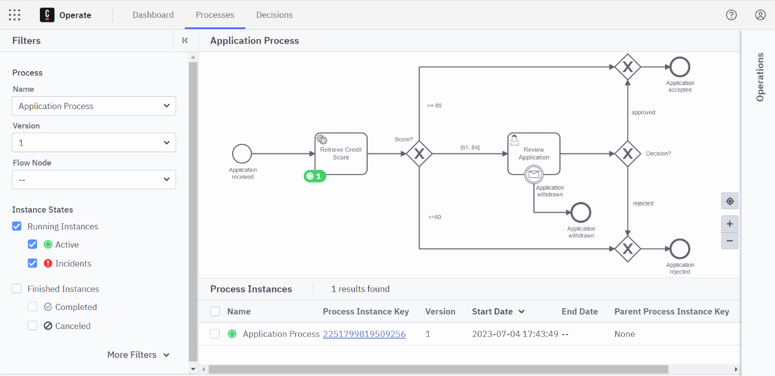
However, we did not specify any variables when starting the process. It is important that the required information about the application is available when the process is started.
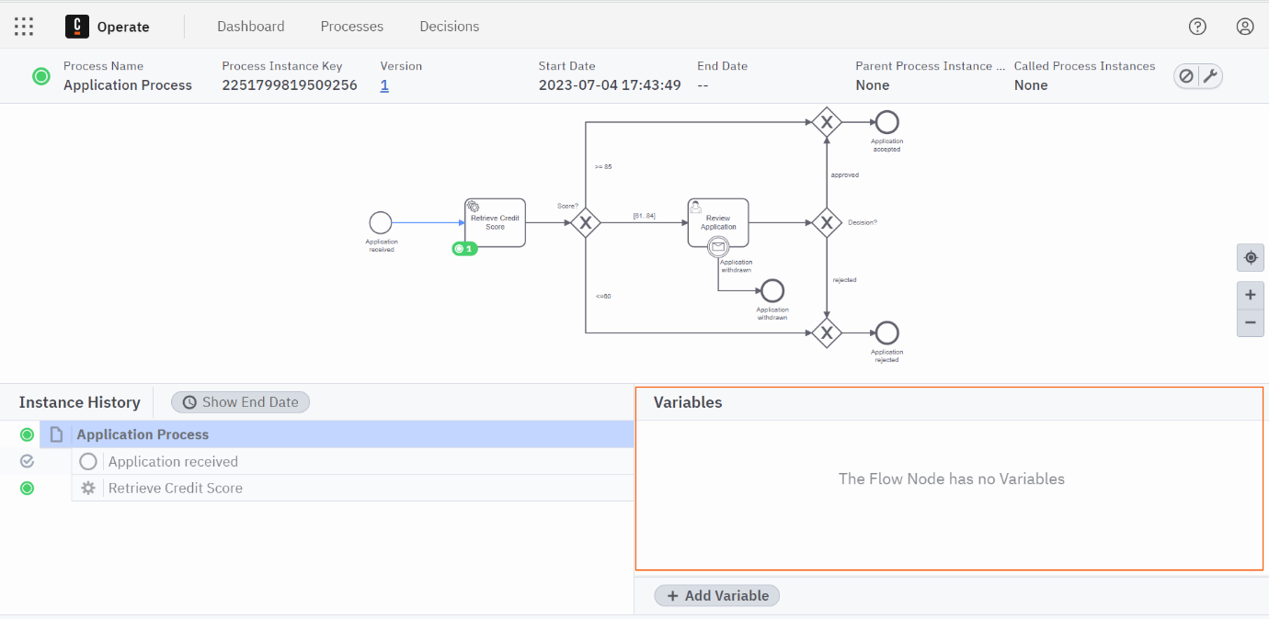
We could now modify the process instance to supply the missing variables. However, in order to keep to a realistic development process we will cancel the current process instance and then start a new one with the required variables.

Cancel a Process Instance
To cancel a Process Instance, we will use CancelProcessInstance RPC. This command cancels an existing process instance.
To cancel the process instance that we just started, you can use the following command:
zbctl cancel instance [processInstanceKey]
Process Instance Key
The process instance key is returned by zbctl when a process is started. Alternatively, you can obtain the process instance key from Operate.
If the instance cancellation was successful, you should see output similar to the below:

Canceled process instance with key '2251799813685254'
Finally, you can see that the process instance has now been cancelled if you refresh Operate.
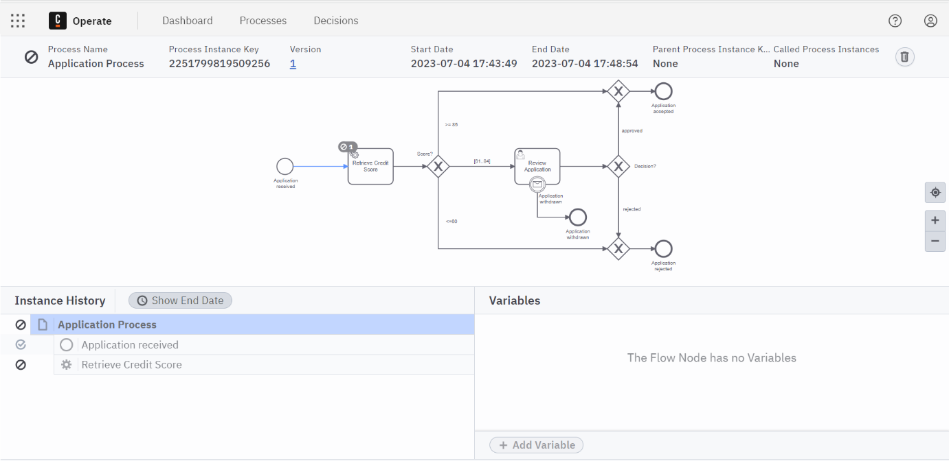

Start a Process Instance with Process Variables
The CreateProcessInstance RPC can be used in conjunction with the --variables flag to specify one or more process variables as a JSON string.

zbctl create instance ApplicationProcess --variables "{\"applicationId\":\"Application-123\",\"applicantName\":\"Camundo Camunda\",\"applicantEmail\":\"camundo@camunda.com\",\"applicantAge\":21}"
Escaping Quotes in Windows Powershell
If the instance creation was successful, you should see output similar to the below:
{
"processDefinitionKey": "2251799813685249",
"bpmnProcessId": "ApplicationProcess",
"version": 1,
"processInstanceKey": "2251799813685260"
}
Process Definition Version
You can also specify the version of the process which should be executed with the --version flag. By default, the latest version of the process will be used if this flag is not passed.
Finally, in Operate, you can now see that the process variables have been correctly passed to the process instance.
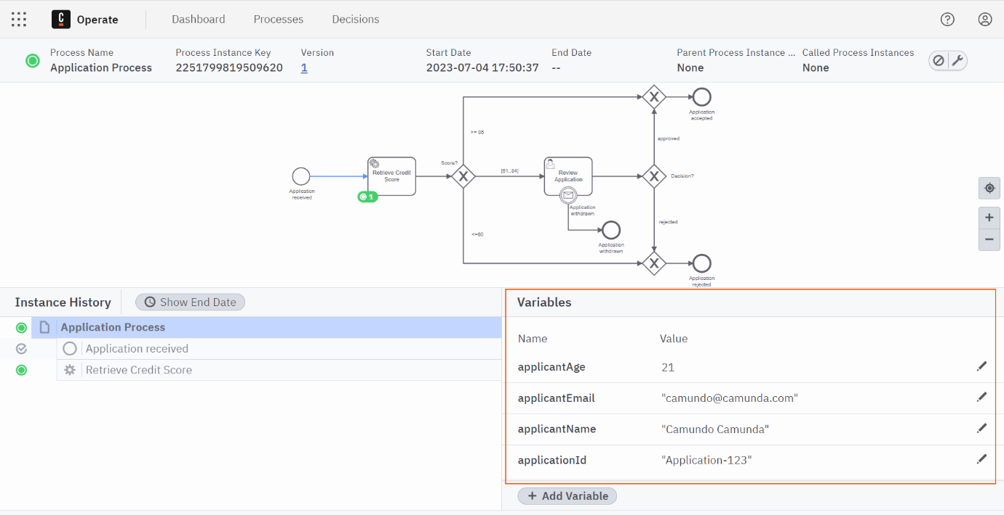
Started and Cancelled a Process Instance
Congratulations! You have successfully started and cancelled a Process Instance using zbctl

Managing Jobs
Overview
Before we start to use zbctl to manage Jobs, let's refresh our knowledge on Incidents, Jobs and Job Workers.

What is an Incident?
An Incident represents a problem in process execution. This means that a process instance is stuck at a particular point, and requires user interaction to resolve the problem.
Incidents are created in different situations, including the following:
- A Job is failed and it has no retries left.
- An input or output variable mapping can't be applied.
- A condition can't be evaluated.
- A decision can't be evaluated.
Errors & Incidents
Not all errors will necessarily lead to Incidents. For example, unexpected errors in Zeebe do not always result in Incidents.

What is a Job?
A Job represents a task that needs to be performed by a process. For example, a Job is created by Zeebe whenever a process instance reaches a Service Task. A Job representing the Service Task must be completed before the process is able to continue.
Jobs have the following properties:
Name | Description
Type | Describes the work item and is defined in each task in the process. The type is referenced by workers to request the jobs they are able to perform.
Custom Headers | Additional static metadata that is defined in the process. Custom headers are used to configure reusable job workers (e.g. a notify Slack worker might read out the Slack channel from its header.)
Key | Unique key to identify a job. The key is used to hand in the results of a job execution, or to report failures during job execution.
Variables | The contextual/business data of the process instance required by the worker to do its work.

What is a Job Worker?
A Job Worker is a service capable of performing a particular task in a process. Job Workers are used to manage the interactions between the Zeebe Engine and the outside world and perform the following actions:
- Request Jobs - Request jobs of a certain type on a regular interval (i.e. polling). This interval and the number of jobs requested are configurable.
- Complete or Fail Jobs - After working on an Activated Job, a Job Worker informs Zeebe that the Job has either Completed or failed.
Complete or Fail
A Job Worker may either Complete or Fail a Job.
- Complete - When the Job Worker completes its work, it sends a complete job command along with any variables, which in turn is merged into the process instance. This is how the Job Worker exposes the results of its work.
- Fail - If the Job Worker cannot successfully complete its work, it sends a fail job command along with an error message.
Activate Job
To activate a Job, we will use the ActivateJobs RPC.
What is Job Activation?
A Job represents a task which needs to be completed in order for the process to continue. Activating a Job makes it available to a Zeebe Client for processing so that it can be either Completed or Failed. An Activated Job is a Job that has been assigned to a specific Zeebe Client.

Activate a Job
We can activate Jobs for the creditscore type in our process by issuing the following command:
zbctl activate jobs creditscore
If the activation was successful, you should see output similar to the below. This includes information about the process instance and the variables associated with that process instance.
{
"jobs": [
{
"key": "2251799819509629",
"type": "creditscore",
"processInstanceKey": "2251799819509620",
"bpmnProcessId": "ApplicationProcess",
"processDefinitionVersion": 1,
"processDefinitionKey": "2251799813685249",
"elementId": "Activity_0jpftwp",
"elementInstanceKey": "2251799813685268",
"customHeaders": "{}",
"worker": "zbctl",
"retries": 3,
"deadline": "1640870839966",
"variables": "{\"applicantAge\":21,\"applicantName\":\"Camunda Camunda\",\"applicationId\":\"Application-123\",\"applicantEmail\":\"camundo@camunda.com\"}"
}
]
}
No Jobs Returned
You may receive output similar to the below if there are no Jobs available for activation.
{
"jobs": []
}
If this is the case, you can simply start a new process instance using the zbctl create instance ApplicationProcess command from a previous lesson.
This Job will now be assigned to a client until the time specified in the deadline has passed; the next step is to either Complete or Fail the Job. If no action is taken before the deadline, the Job will become eligible for activation by another client.

Configuring Job Activation
Further information on the parameters that are most commonly used in conjunction with the ActivateJobs RPC can be found below.
Name | Description
maxJobsToActivate | Specify the maximum amount of jobs to activate (default 1)
requestTimeout | Specify the request timeout for a long polling interval. With long polling, a request will be kept open while no jobs are available. The request is completed when at least one job becomes available
timeout | Specify the maximum time that a service takes to complete the job. Once the timeout is reached (default 5m0s), the job can be done by a different worker again. Zeebe assumes that the worker died during execution.
variables | Specify the list of variable names which should be fetch on job activation (comma-separated), which can decrease load and improve performance
worker | Specify the name of the worker (default "zbctl"), mostly used for logging purposes.
Activated a Job
Congratulations! You have successfully activated a Job using zbctl

Complete Job
To complete a Job, we will use the CompleteJob RPC. This command completes a Job with the provided payload and allows for completion of the associated Service Task.
What is Job Completion?
An Activated Job represents a task that has been assigned to a Zeebe Client which needs to be completed in order for the process to continue. Completing an Activated Job informs Zeebe that the task has now been completed and execution can continue.

Complete a Job
We can complete the previously activated Job by issuing the command below.
zbctl complete job [jobKey] --variables "{\"score\":90}"
- [jobKey] should be replaced with the key that was returned by the previously activated Job
- --variables "{\"score\":90}" creates a new Process Variable named score and sets the value to 90
If the completion was successful, you should see output similar to the below. Note that this also includes confirmation that a process variable was updated.
Now, when we look in Operate, we can see that the Job and the Process Instance have been completed:
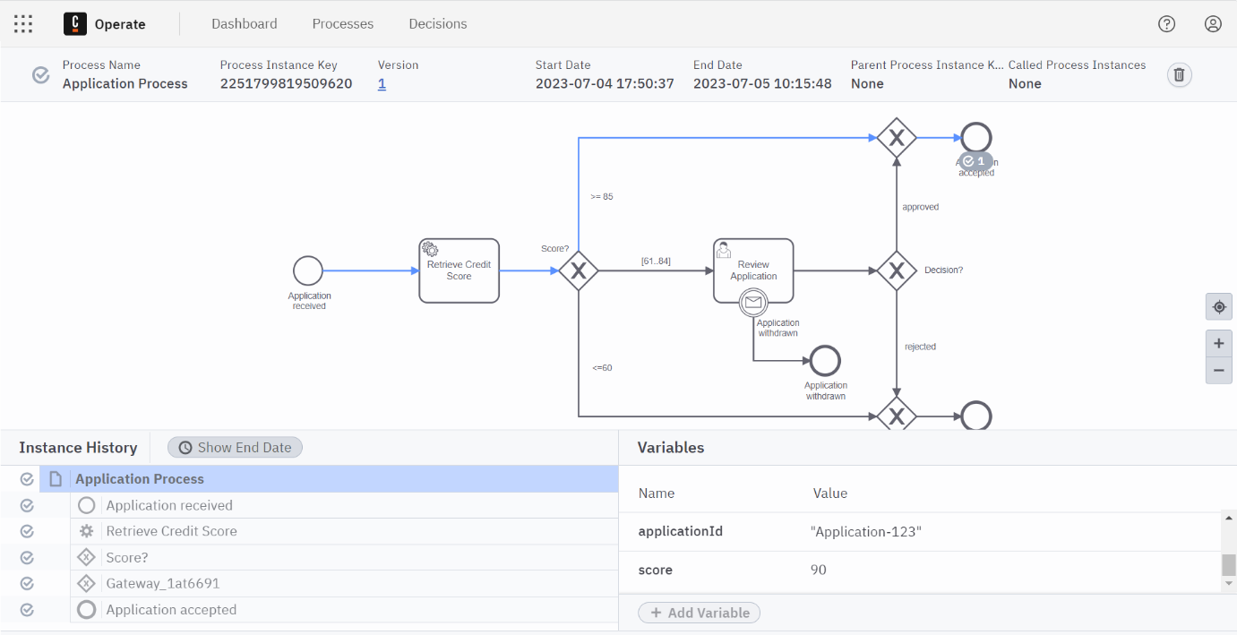
Why did the Process Instance complete?
By setting the score variable to 90, the process token followed the Application Accepted sequence flow as the flow condition has been set to: score >- 85.
Completed a Job
Congratulations! You have successfully completed a Job using zbctl

Fail Job
To fail a Job, we will use the FailJob RPC, this command will also create an Incident if the retries argument is zero or negative.
What is Job Failure?
An Activated Job represents a task that has been assigned to a Zeebe Client which needs to be completed in order for the process to continue. Failing an Activated Job informs Zeebe that the task could not be completed and that further processing is required through either a retry or resolution of an Incident.

Fail a Job
We have already seen how to use the activate and complete commands in zbctl. In this lesson, we will see how to use the fail command to simulate a real-life use case.
The steps that we will follow in the sections below are:
- Start a new Process Instance
- Activate the Job associated with the Process Instance
- Fail the Job and provide a suitable error message
- Review the Incident in Operate
- Retry the Job
- Activate the previously failed Job associated with the Process Instance
- Complete the Job

Start Process Instance
We can start by creating a new process instance with variables using the following command:
zbctl create instance ApplicationProcess --variables "{\"applicationId\":\"Application-123\",\"applicantName\":\"Camundo Camunda\",\"applicantEmail\":\"camunda@camunda.com\",\"applicantAge\":21}"
If the instance creation was successful, you should see output similar to the below:
{
"processDefinitionKey": "2251799813685249",
"bpmnProcessId": "ApplicationProcess",
"version": 1,
"processInstanceKey": "2251799813685280"
}

Activate the Job
We can activate the Job associated with the process instance that we just created using the following command:
zbctl activate jobs creditscore
If the job activation was successful, you should see output similar to the below:
{
"jobs": [
{
"key": "2251799813685285",
"type": "creditscore",
"processInstanceKey": "2251799813685280",
"bpmnProcessId": "ApplicationProcess",
"processDefinitionVersion": 1,
"processDefinitionKey": "2251799813685249",
"elementId": "Activity_0jpftwp",
"elementInstanceKey": "2251799813685284",
"customHeaders": "{}",
"worker": "zbctl",
"retries": 3,
"deadline": "1640872681780",
"variables": "{\"applicantAge\":21,\"applicantName\":\"Camundo Camunda\",\"applicationId\":\"Application-123\",\"applicantEmail\":\"camunda@camunda.com\"}"
}
]
}

Fail the Job
We can now fail the Job that we just activated using the following command:
zbctl fail job [jobKey] --retries 0 --errorMessage "Could not receive score from external service"
- [jobKey] should be replaced with the key that was returned by the previously activated Job
- retries is used to inform Zeebe that the Job should not be retried again
- --errorMessage" is used to create add a human readable error message to the Incident that is created
If failing the Job was successful, you should see output similar to the below:
Failed job with key '2251799813685285' and set remaining retries to '0' and variables '{}' with retry backoff '0s'
Further information on the parameters that are most commonly used in conjunction with the FailJobs RPC can be found below.
Name | Description
retries | The amount of retries the job should have left
retryBackoff | The backoff timeout (in ms) for the next retry
errorMessage | An optional message describing why the job failed. This is particularly useful if a job runs out of retries and an incident is raised, as it this message can help explain why an incident was raised
Job Retry Behaviour
A different action will be taken by Zeebe depending on the value that was specified for retries in the above
- If retries is greater than zero, the job is retried and reassigned.
- If retries is zero or negative, an incident is raised and the job is not retried until the incident is resolved.

View the Incident in Operate
If you now launch Operate, you will see that the Process Instance that you launched is now showing an Incident.
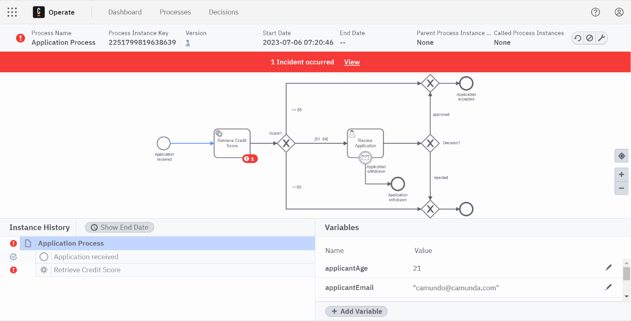
In the Detail View, you can also see the error message that we provided via zbctl
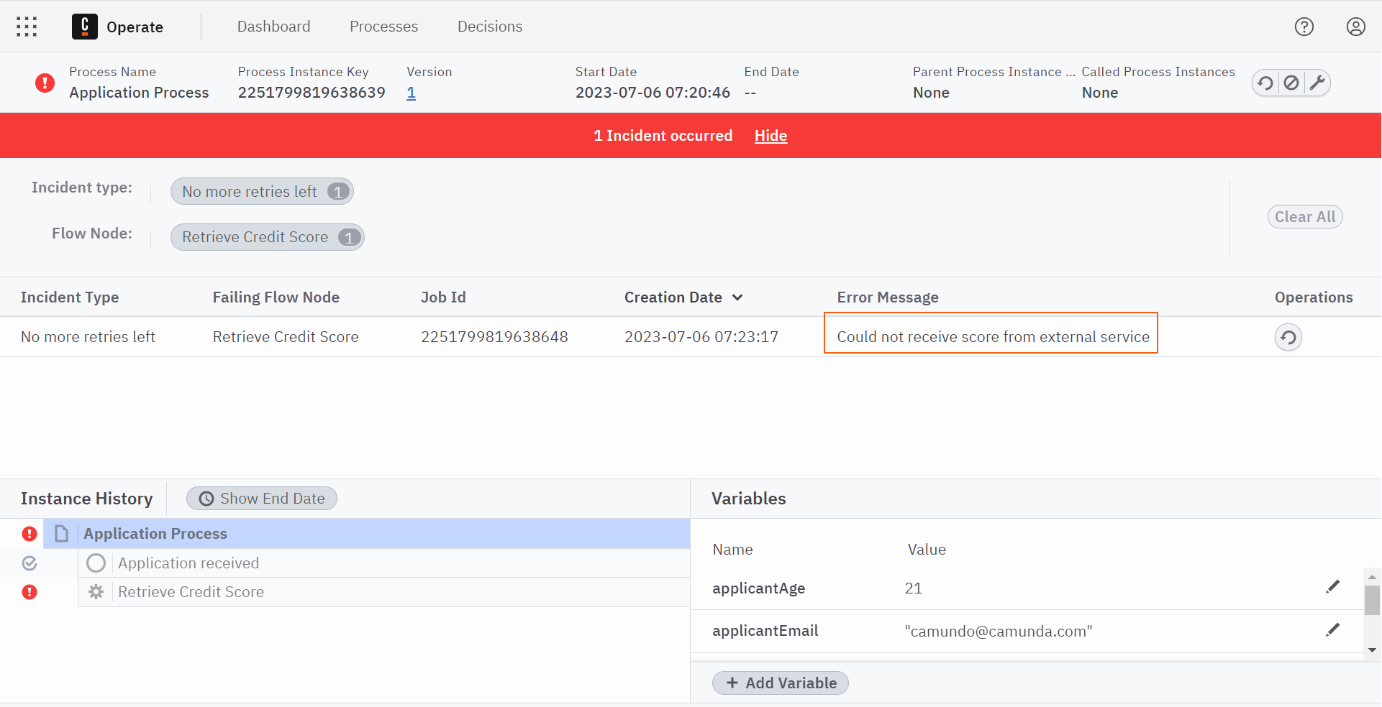

Retry the Incident
We can now retry the Incident in Operate so that we can continue with our example and successfully complete the Job.
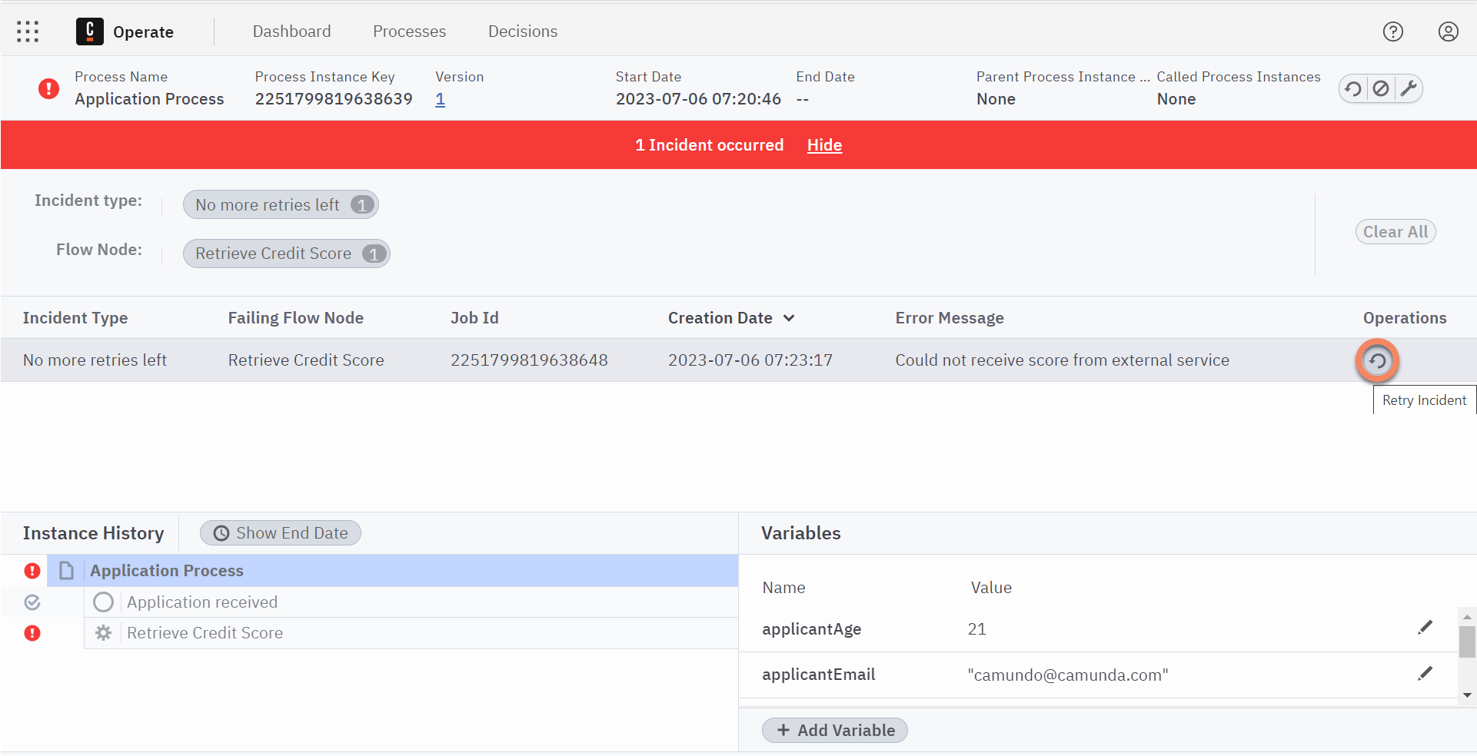
Resolve Incident
It is also possible to resolve an Incident using zbctl and the ResolveIncident RPC
This can be achieved by passing the ID of the Incident to zbctl as can be seen below:
zbctl resolve incident 2251799821886326

Activate the Job (Again)
We can now re-activate the previously job using the following command:
zbctl activate jobs creditscore
If the job activation was successful, you should see output similar to the below:
{
"jobs": [
{
"key": "2251799813685285",
"type": "creditscore",
"processInstanceKey": "2251799813685280",
"bpmnProcessId": "ApplicationProcess",
"processDefinitionVersion": 1,
"processDefinitionKey": "2251799813685249",
"elementId": "Activity_0jpftwp",
"elementInstanceKey": "2251799813685284",
"customHeaders": "{}",
"worker": "zbctl",
"retries": 3,
"deadline": "1640872681780",
"variables": "{\"applicantAge\":21,\"applicantName\":\"Camundo Camunda\",\"applicationId\":\"Application-123\",\"applicantEmail\":\"camunda@camunda.com\"}"
}
]
}

Complete the Job
This time, instead of failing the Job we will use the complete command which will allow the process instance to complete:
zbctl complete job [jobKey] --variables "{\"score\":60}"
If the job completion was successful, you should see output similar to the below:
Completed job with key '2251799813685529' and variables '{"score":60}'

View the Process Instance in Operate
If you now launch Operate, you will see that the Process Instance that you launched is now showing as complete and that the application was rejected..
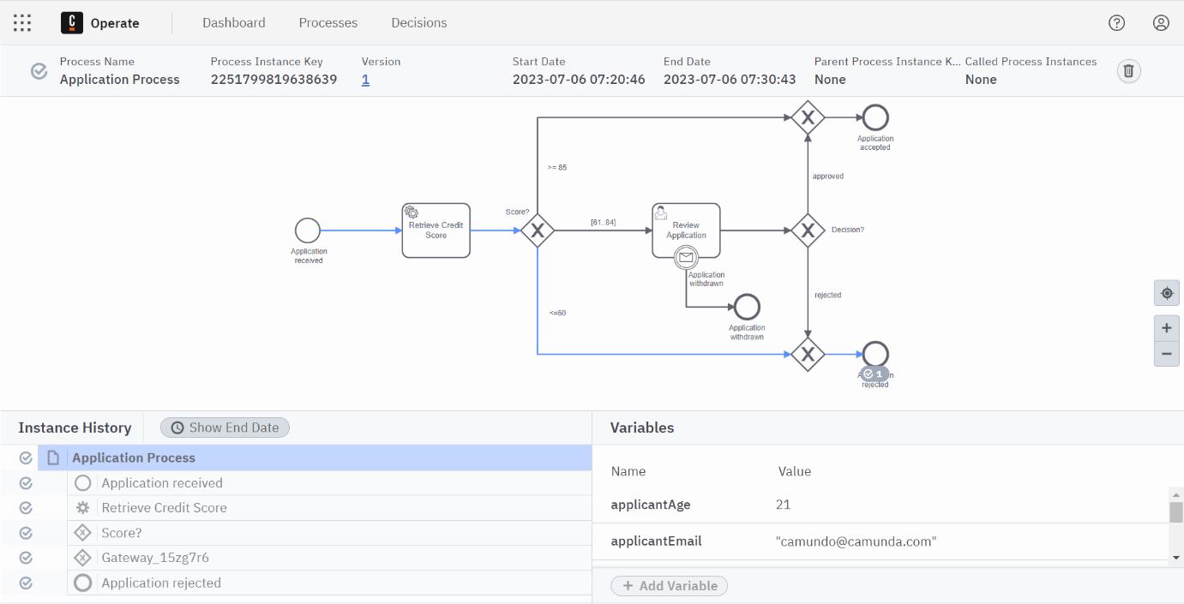
Failed a Job
Congratulations! You have successfully failed a Job using zbctl

Managing Workers
Create Worker
In the last section, you saw how zbctl can be used to activate, complete and fail jobs that are created by Zeebe.
However, in practice it would be unusual for a Developer or an Administrator to handle the low level lifecycle of a Job as Camunda provides several Official Zeebe Clients which provide a high level abstractions over the Zeebe API and other utility / convenience functions that you would expect to find in a client library.
We will now use zbctl to create a Job Worker which will process Jobs from the Retrieve Credit Score Service Task. This Job Worker will combine the activate and complete commands from the previous lessons into a single worker.

Create a Worker
In the earlier Outline Solution lesson we saw that the Retrieve Credit Score Service Task needs to return a Credit Score between 0 and 100.
This time, instead of issuing low level commands (activate, complete and fail) using zbctl, we will create a Job Worker which will complete the Service Task instead.

Create a Process Instance
We can start by creating a new process instance using the following command:
zbctl create instance ApplicationProcess --variables "{\"applicationId\":\"Application-123\",\"applicantName\":\"Camundo Camunda\",\"applicantEmail\":\"camundo@camunda.com\",\"applicantAge\":21}"
If the instance creation was successful, you should see output similar to the below:
{
"processDefinitionKey": "2251799813685249",
"bpmnProcessId": "ApplicationProcess",
"version": 1,
"processInstanceKey": "2251799813685540"
}

Create a Job Worker for Retrieve Credit Score
We will now create a Job Worker which will always return a score of 80 to the process instance by issuing the following command:
zbctl create worker creditscore --handler "echo {\"score\":80}"

If the worker creation was successful, you should see output similar to the below:
2023/09/13 16:54:13 Activated job 2251799814701216 with variables {"applicantAge":21,"applicantName":"Camundo Camunda","applicationId":"Application-123","applicantEmail":"camundo@camunda.com"}
2023/09/13 16:54:13 Handler completed job 2251799814701216 with variables {"score":80}

You can see that the Job was acquired and completed by the Job Worker without any need to issue the low level activate, complete and fail commands.

What just happened?
The zbctl create worker command created a polling Job Worker which calls the provided handler for every Job. The handler will receive the variables of the Activated Job as a JSON object. If the handler completes successfully, the Job will be completed with the variables provided. Otherwise, if the handler exists with a non-zero exit code the Job will be failed.

Windows Command Line
If you are using the Windows Command Line you may need to take a different approach to implement the handler. An example has been provided below:
Create a creditScore.bat file which contains the following JSON:
@echo off
echo {"score":80}
Create the Job Worker using:
zbctl create worker creditscore --handler .\creditScore.bat

Configuring the Job Worker
Further information on the parameters that are most commonly used in conjunction with creating a Job Worker can be found below.
Name | Description
concurrency | Specify the maximum number of concurrent spawned go routines to complete jobs
handler | Specify handler to invoke for each job. The handler will then complete the job with its result or fail the job if it encounters a problem while processing the job
maxJobsActive | Specify the maximum number of jobs which will be activated for this worker at the same time
name | Specify the worker name
pollInterval | Specify the maximal interval between polling for new jobs
pollThreshold | Specify the threshold of buffered activated jobs before polling for new jobs, i.e. pollThreshold * maxJobsActive
requestTimeout | Specify the timeout for a request
timeout | Specify the duration no other worker should work on job activated by this worker

Verify in Operate
If you now launch Operate, you will see that the Process Instance that you launched has now moved to the Review Application task.
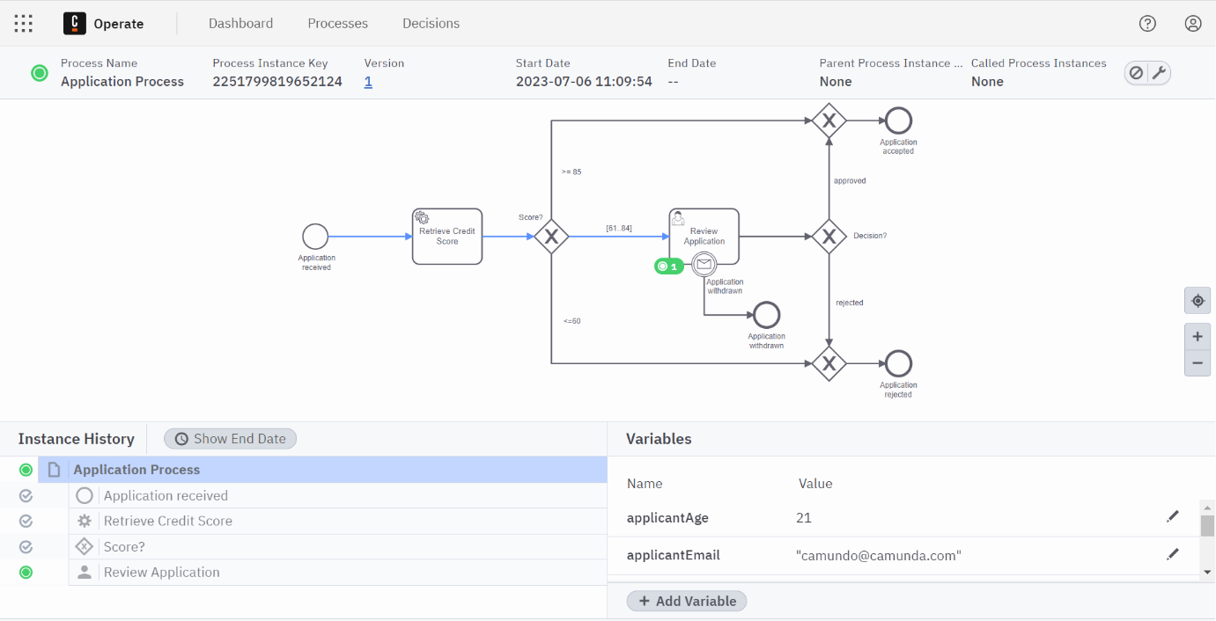

Complete the User Task
Since the User Task Review Application is currently active, it must be completed.
A Job Worker can subscribe to the Job Type io.camunda.zeebe:userTask to complete the Job manually. When the Job is completed, the User Task is completed and the process instance continues.
zbctl create worker io.camunda.zeebe:userTask --handler "echo {\"approved\":true}"
If the worker creation was successful, you should see output similar to the below:
2023/09/13 18:12:45 Activated job 2251799814704618 with variables {"applicantAge":21,"applicantName":"Camundo Camunda","applicationId":"Application-123","applicantEmail":"camundo@camunda.com"}
2023/09/13 18:12:45 Handler completed job 2251799814704618 with variables {"approved":true}
Windows Command Line
If you are using the Windows Command Line you may need to take a different approach to implement the handler. An example has been provided below:
Create a reviewApplication.bat file which contains the following JSON:
@echo off
echo {"approved":true}
Create the Job Worker using:
zbctl create worker io.camunda.zeebe:userTask --handler .\reviewApplication.bat

Finally, in Operate, you can see that the process instance has now completed.
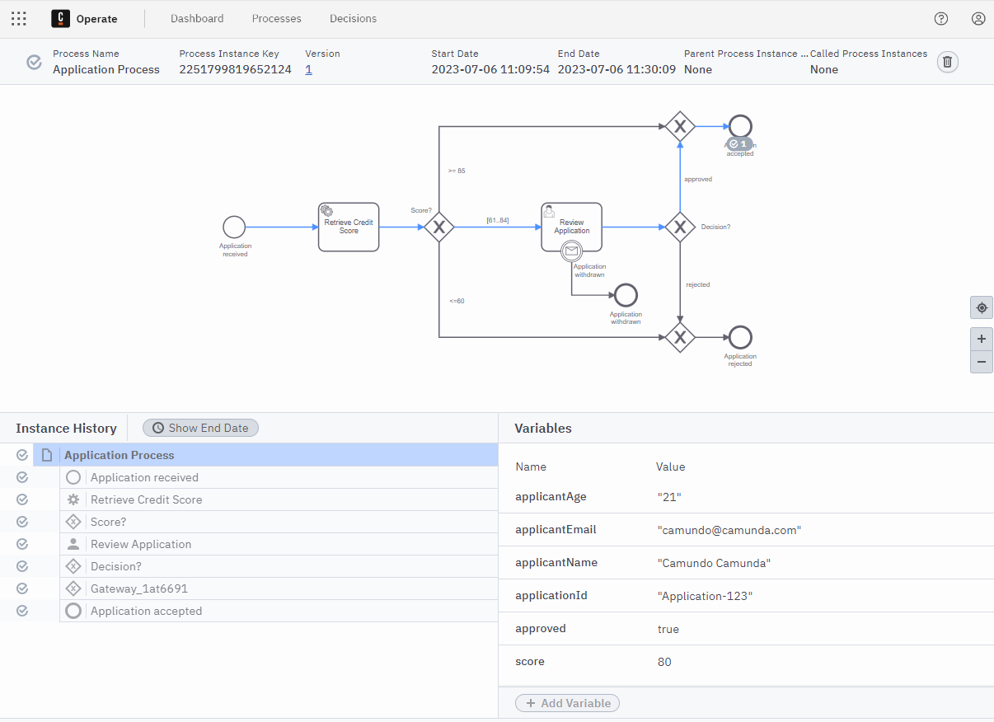
Created a Worker
Congratulations! You have successfully used zbctl to create a Job Worker and to also complete the Review Application User Task.

Managing Messages
Publish Message
You should now be able to perform the following tasks using zbctl:
- Deploy a Process Definition
- Start a Process Instance
- Cancel a Process Instance
- Activate, Complete and Fail a Job
- Create a Job Worker
In this final lesson, you will see how to publish a message using the PublishMessage RPC. This will allow an application in manual processing to be withdrawn.
What is Message Correlation?
Process instances can be notified of incoming messages through Start, Boundary and Intermediate Events. However, the message must be mapped to the correct process instance using a process called Message Correlation.
A message is not sent to a process instance directly. Instead, the message correlation is based on subscriptions that contain the message name and the correlation key (also known as the correlation value).

Prepare a Process Instance

Start a Process Instance
Start a new process instance using the following command:
zbctl create instance ApplicationProcess --variables "{\"applicationId\":\"Application-001\",\"applicantName\":\"Camundo Camunda\",\"applicantEmail\":\"camundo@camunda.com\",\"applicantAge\":21}"

If the instance creation was successful, you should see output similar to the below:
{
"processDefinitionKey": "2251799813685249",
"bpmnProcessId": "ApplicationProcess",
"version": 1,
"processInstanceKey": "2251799813685254"
}
Correlation Key
We will be using the Application Id as a Correlation Key so you should ensure that this value is unique when starting the process instance i.e. you will need to increment the Application Id if you work through this lesson several times.

Start the Job Worker
Start a Job Worker which will always return a score of 80 to the process instance by issuing the following command:
zbctl create worker creditscore --handler "echo {\"score\":80}"
If the worker creation was successful, you should see output similar to the below:
2023/09/13 16:54:13 Activated job 2251799814701216 with variables {"applicantAge":21,"applicantName":"Camundo Camunda","applicationId":"Application-001","applicantEmail":"camundo@camunda.com"}
2023/09/13 16:54:13 Handler completed job 2251799814701216 with variables {"score":80}

Publish a Message
We can now publish a Message to Zeebe using the applicationId as a Correlation Key.
zbctl publish message "Application withdrawn" --correlationKey "Application-001"

If the publication was successful, you should see output similar to the below:
{
"key": "2251799813685665"
}

Verify in Operate
Finally, in Operate, you can see that the User Task has been cancelled and that the process is now completed at Application Withdrawn.
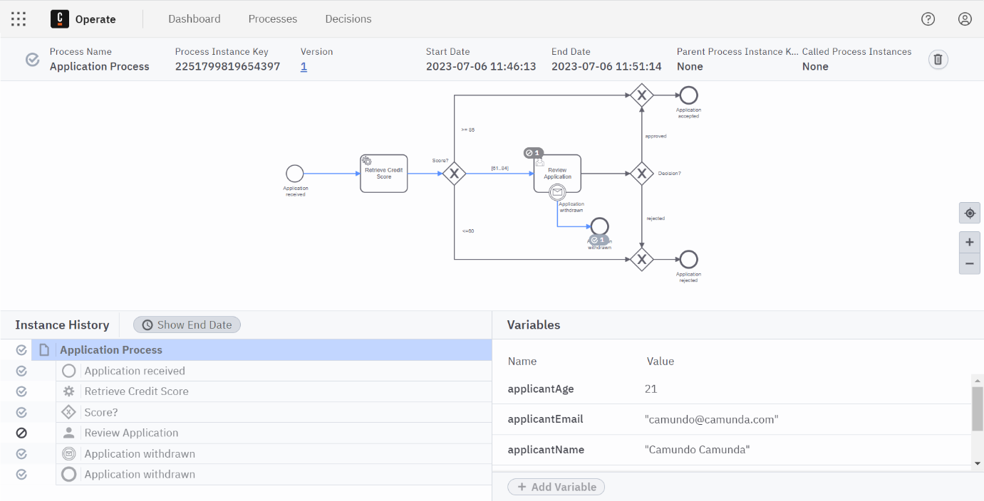
Published a Message
Congratulations! You have successfully published a Message using zbctl

Validation
Cleanup Environment
We have now met all of the business requirements that have been defined in our Scenario. We are now in a position where we can perform an end-to-end test of our process to ensure that everything is working as expected.
However, as we have been testing our process definition using zbctl it is likely that we have several incomplete process instances still running. Having incomplete (and possibly incorrect) process instances running in our environment may make it more difficult to confirm that everything is working as expected in an end-to-end test.
We will now Cancel and Delete any remaining instances so that we have a completely clean environment in which we can conduct our acceptance tests.

Cancel & Delete Process Instances

Launch Operate
Launch Operate by following the steps below:
- From the Console, select Clusters
- Select Camundanzia from the Clusters page
- Click the Launch link next to Operate in the Cluster Details page
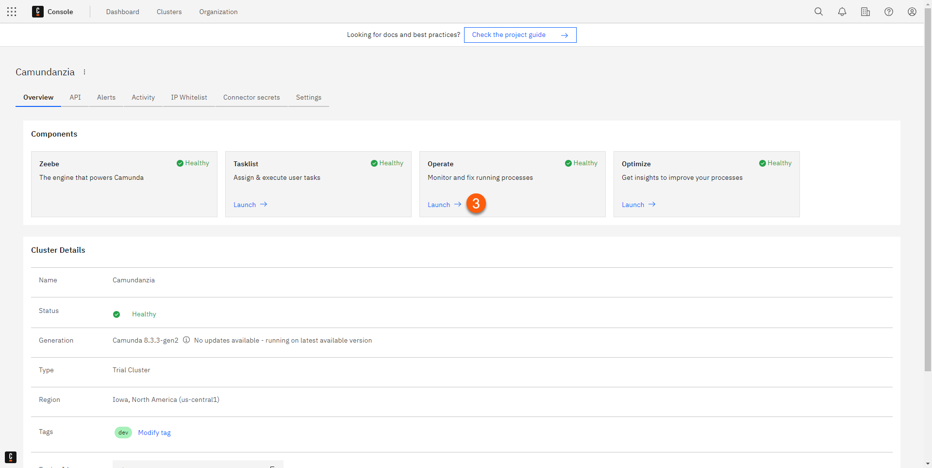
- After a few seconds, the Operate Dashboard will be displayed

Cancel Process Instances
We can now Cancel the process instances in Operate by following the steps below:
- Click on Application Process from the Instances by Process panel on the left-hand side of the screen
- On the bottom left of the screen is a series of filters that will allow you to select Running or Finished process instances
- Ensure that the Running filters are selected and the Finished filters are not selected
- Then, for each Process Instance that is shown in the Instances panel, click the Cancel Instance button to the right-hand side of the process
No Running Processes
This section can be skipped if there are no running processes shown in the Instances panel.
- The Process Instance will then be cancelled and will disappear from the Instances panel
What happened to the Process Instance?
When you Cancel a process in Operate it changes to a stopped state. As the process is no longer running it is not picked up by Running filter.
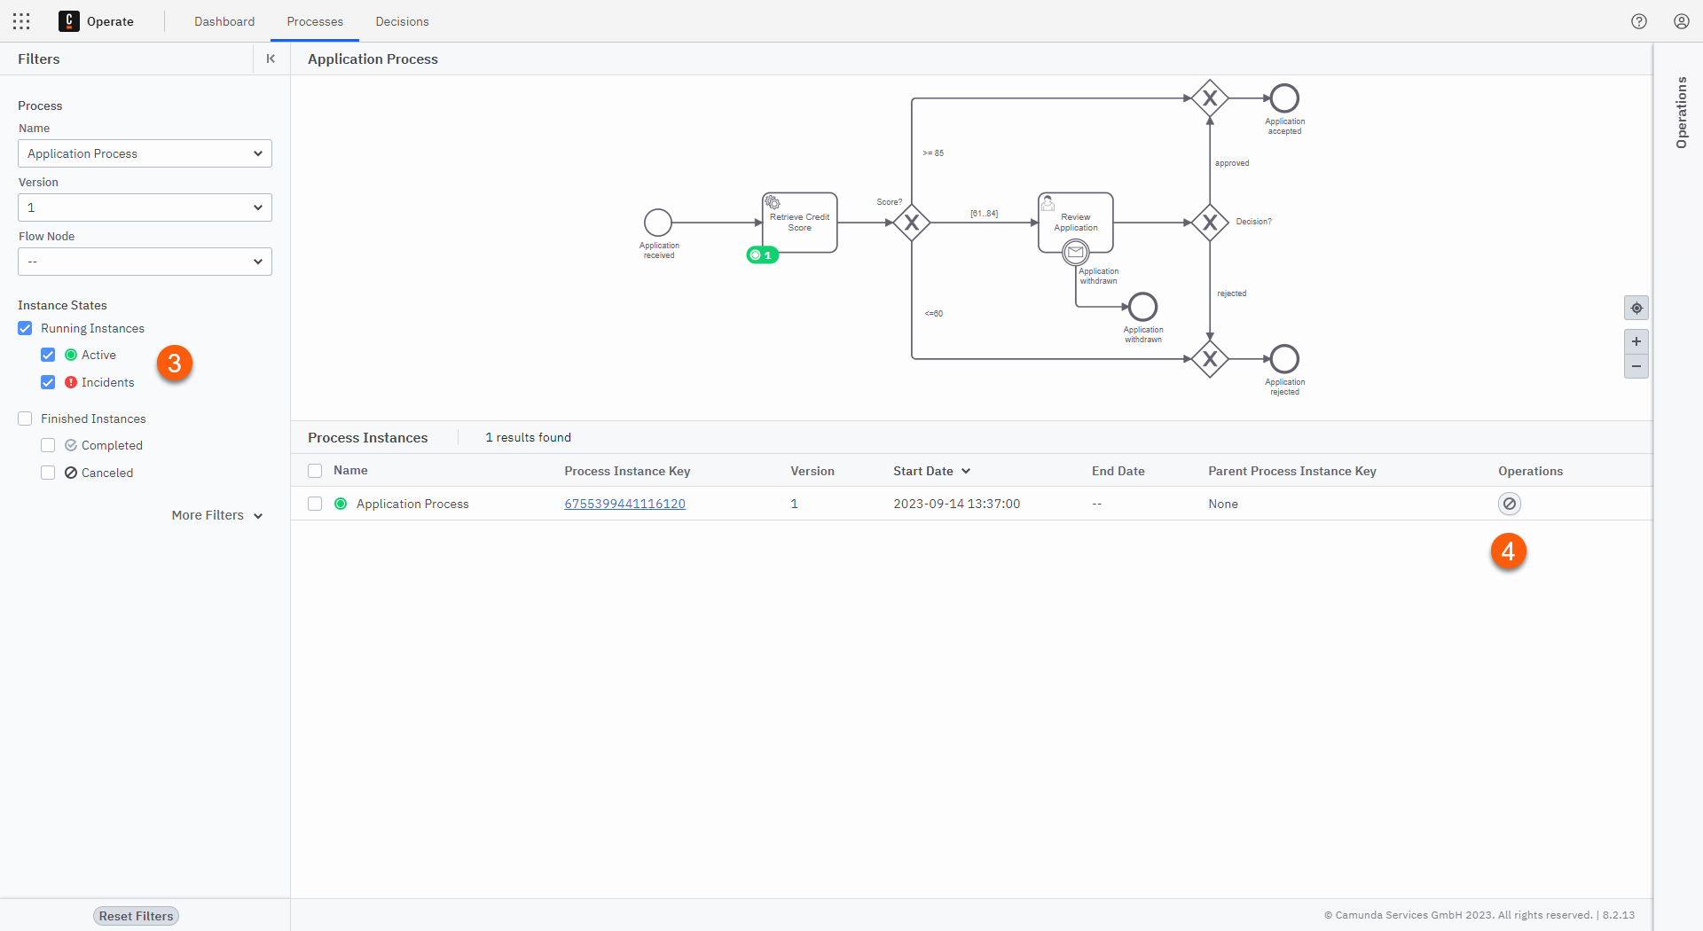

Delete Process Instances
We can now Delete the finished process instances in Operate by following the steps below:
- On the bottom left of the screen is a series of filters that will allow you to select Running or Finished process instances
- Ensure that the Finished filters are selected and the Running filters are not selected
- Then, for each Process Instance that is shown in the Instances panel, click the Delete Instance button to the right-hand side of the process
- The Process Instance will then be deleted and will disappear from the Instances panel
What happened to the Process Instance?
When you Delete a process in Operate it is completely removed from the Zeebe Engine.
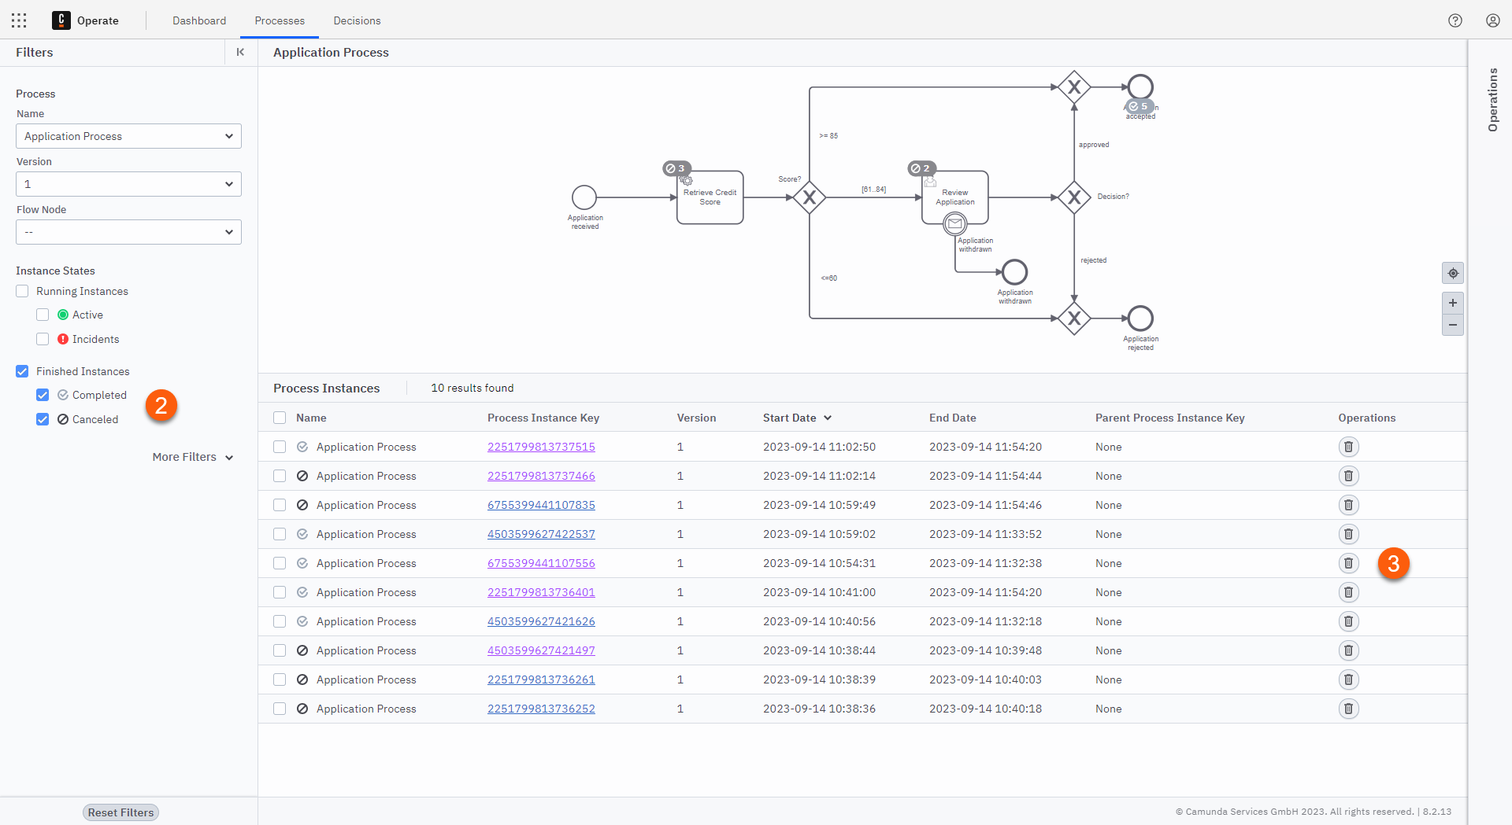

Cleaned the Environment
Congratulations! You have now removed all instances of Application Process from the environment.

Test Process
We are now ready to test the Application Process end-to-end.

Review Acceptance Criteria
Let's start by reviewing the acceptance criteria that was defined earlier; we need to ensure that all of the requirements below can be met by our modifications and understanding.
- An Applicant is able to submit a Car Insurance Application
- The Credit Score of the Applicant can be retrieved automatically
- A Clerk is able to review complex applications and decide whether the Applicant will be accepted or not
- An Applicant is able to cancel their application

Test Scenarios
The following scenarios will be required to fully confirm that the acceptance criteria above has been met.

Test Application

Test Scenarios
Five scenarios will be required to confirm that the acceptance criteria above has been met.
Test Scenario | Application Id | Applicant Name | Applicant Email | Applicant Age | Score | Expected Result
1 - Application Accepted | CMD000001 | Accepted | 001@camunda.com | 21 | 90 | Accepted
2 - Application Reviewed & Approved | CMD000002 | Accepted | 002@camunda.com | 22 | 80 | Accepted
3 - Application Reviewed & Rejected | CMD000003 | Rejected | 003@camunda.com | 23 | 80 | Rejected
4 - Application Rejected | CMD000004 | Rejected | 004@camunda.com | 24 | 50 | Rejected
5 - Application Withdrawn | CMD000005 | Withdrawn | 005@camunda.com | 25 | 80 | Withdrawn

Launch Process Instances
Start five instances of the Application Process by issuing the following commands:
zbctl create instance ApplicationProcess --variables "{\"applicationId\":\"CMD0000001\",\"applicantName\":\"Accepted\",\"applicantEmail\":\"001@camunda.com\",\"applicantAge\":21,\"score\":90}"
zbctl create instance ApplicationProcess --variables "{\"applicationId\":\"CMD0000002\",\"applicantName\":\"Accepted\",\"applicantEmail\":\"002@camunda.com\",\"applicantAge\":22,\"score\":80,\"approved\":true}"
zbctl create instance ApplicationProcess --variables "{\"applicationId\":\"CMD0000003\",\"applicantName\":\"Rejected\",\"applicantEmail\":\"003@camunda.com\",\"applicantAge\":23,\"score\":80,\"approved\":false}"
zbctl create instance ApplicationProcess --variables "{\"applicationId\":\"CMD0000004\",\"applicantName\":\"Rejected\",\"applicantEmail\":\"004@camunda.com\",\"applicantAge\":24,\"score\":50}"
zbctl create instance ApplicationProcess --variables "{\"applicationId\":\"CMD0000005\",\"applicantName\":\"Withdrawn\",\"applicantEmail\":\"005@camunda.com\",\"applicantAge\":25,\"score\":80}"
Process Variables
In order to simplify our testing, we will populate all process variables when each new instance is started. In the real-world, a Job Worker would be developed that encapsulates the Retrieve Credit Score business logic; a Clerk would also be responsible for making the decision on whether the application has been approved or rejected.

Launch Job Worker for Retrieve Credit Score
Launch a Job Worker to complete the Retrieve Credit Score tasks by issuing the following command:
zbctl create worker creditscore --handler "echo"
Echo?
The --handler is a required parameter for creating a new worker; we have used "echo" as the simplest possible implementation here as we have already pre-populated the correct variables on each process instance.

If the worker creation was successful, you should see output similar to the below:
2023/09/15 08:46:33 Activated job 2251799813808253 with variables {"score":80,"applicantAge":25,"applicantName":"Withdrawn","applicationId":"CMD0000005","applicantEmail":"005@camunda.com"}
2023/09/15 08:46:33 Activated job 2251799813808227 with variables {"score":80,"approved":false,"applicantAge":23,"applicantName":"Rejected","applicationId":"CMD0000003","applicantEmail":"003@camunda.com"}
2023/09/15 08:46:33 Activated job 4503599627493422 with variables {"score":50,"applicantAge":24,"applicantName":"Withdrawn","applicationId":"CMD0000004","applicantEmail":"004@camunda.com"}
2023/09/15 08:46:33 Activated job 6755399441178676 with variables {"score":90,"applicantAge":21,"applicantName":"Accepted","applicationId":"CMD0000001","applicantEmail":"001@camunda.com"}
2023/09/15 08:46:33 Handler completed job 6755399441178676 with variables {}
2023/09/15 08:46:33 Activated job 6755399441178688 with variables {"score":80,"approved":true,"applicantAge":22,"applicantName":"Accepted","applicationId":"CMD0000002","applicantEmail":"002@camunda.com"}
2023/09/15 08:46:33 Handler completed job 4503599627493422 with variables {}
2023/09/15 08:46:33 Handler completed job 2251799813808227 with variables {}
2023/09/15 08:46:33 Handler completed job 2251799813808253 with variables {}
2023/09/15 08:46:34 Handler completed job 6755399441178688 with variables {}

Publish a Message
Publish a Message to Zeebe using the applicationId as a Correlation Key.
zbctl publish message "Application withdrawn" --correlationKey "CMD0000005"

If the publication was successful, you should see output similar to the below:
{
"key": "2251799813685665"
}

Complete the Review Application User Task
Launch a Job Worker to complete the Review Application tasks by issuing the following command:
zbctl create worker io.camunda.zeebe:userTask --handler "echo"
Echo?
The --handler is a required parameter for creating a new worker; we have used "echo" as the simplest possible implementation here as we have already pre-populated the correct variables on each process instance.
If the worker creation was successful, you should see output similar to the below:
2023/09/15 08:47:19 Activated job 2251799813808276 with variables {"score":80,"approved":false,"applicantAge":23,"applicantName":"Rejected","applicationId":"CMD0000003","applicantEmail":"003@camunda.com"}
2023/09/15 08:47:19 Activated job 6755399441178734 with variables {"score":80,"approved":true,"applicantAge":22,"applicantName":"Accepted","applicationId":"CMD0000002","applicantEmail":"002@camunda.com"}
2023/09/15 08:47:19 Handler completed job 2251799813808276 with variables {}
2023/09/15 08:47:19 Handler completed job 6755399441178734 with variables {}

Review Test Scenarios
We can now review the results from the test scenarios to confirm that everything is working as expected.
- Launch Operate by following the steps in the previous lesson. Alternatively, refresh the window if you still have Operate open.
- Click on Application Process from the Process Instances by Name panel on the left-hand side of the screen
- Check the Finished Instances filter on the left hand side of the screen to show completed process instances. If everything has worked as expected you should now see five completed process instances on the screen.
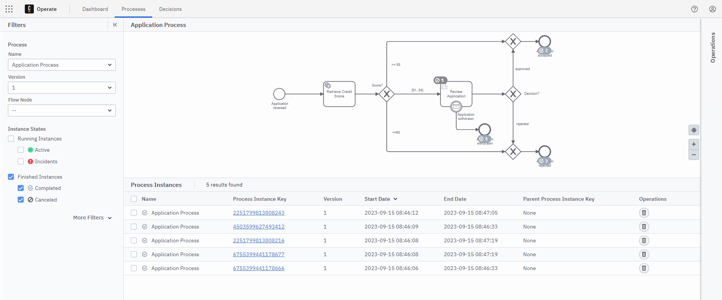
- Click on each of the Process Instance Keys in the bottom part of the screen to open up the Process Instance View
- You should now be able to confirm that each of the scenarios above has been executed successfully.
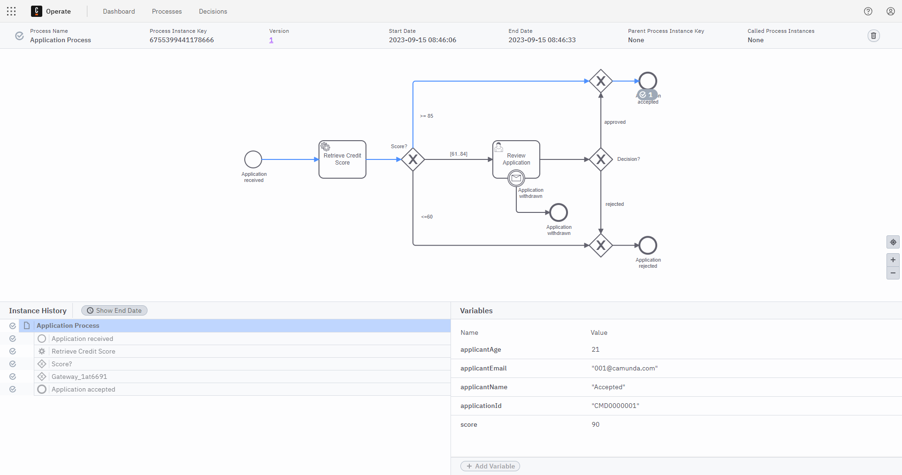

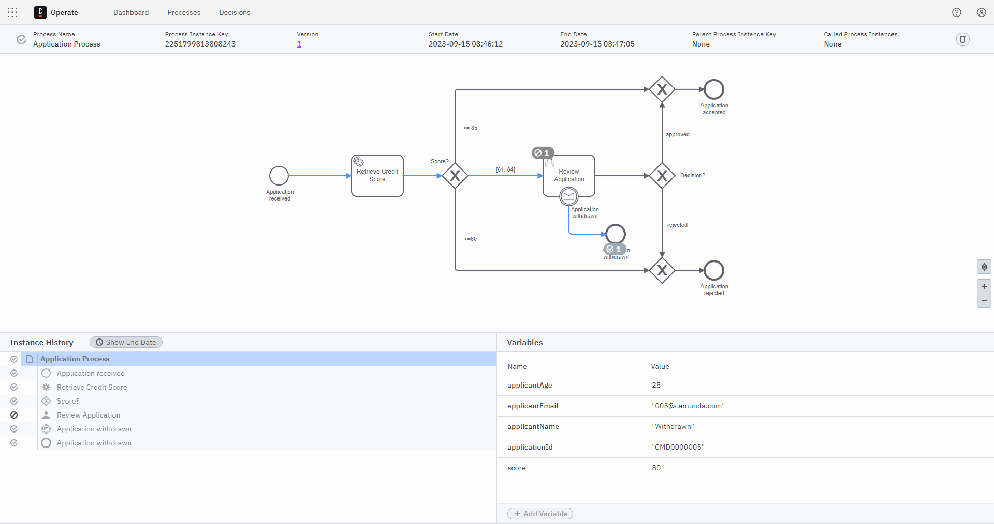

Tested Car Insurance Request
Congratulations! You have now confirmed that the Application Process meets the acceptance criteria which was specified at the start of the course.

